Topic: My home - is my castle (Мій дім – моя фортеця)

Objectives: to develop pupils' speaking and listening skills;
to learn and practice using active vocabulary on the topic;
to learn grammar structure (Conditionals)
to develop pupils' readiness for taking part in the process of English communication;
to incorporate team work;

Aids: Student’s book Real life intermediate, Workbook Real life intermediate, cards with pictures of the houses, cards with grammar tasks, movie about kinds of houses,a card with crossword puzzle

Procedure:
- Warming Up: Good morning, students. I am glad to see you. How are you today?
Today we will talk about kinds of houses. Have you ever heard the saying My Home is my castle? Can you explain why home is associated with the castle?
- Checking home task: What was your home task for today? Let’s check it. Did you read the letter of enquiry? Was it difficult?
- Vocabulary Practice:

Put the words into the categories: type of house, inside, outside, additional features, owners and people who live in the house

Detached
Semi-detached
A terraced house
igloo
caravan
castle
bungalow
cottage
villa
skyscraper
farmhouse
tent
Chimney
Attic
Roof
block of flats
landlord
basement
Storey (floor)
palace
mansion
bedsit
Hedge

A tenant
Fence

IV Speaking and Watching Video

Let’s watch a video about the types of houses that people have in the USA

Do we have such houses in Ukraine?

What kind of house do you live in? What house do you like most of all?

Look at the pictures and say which building do you think is the strangest. Which one do you like best of all?
Look at the pictures on the cards and match the explanations to the words

- Reading and Listening
Read the description in Ex. 3 and underline the words from active vocabulary. Which building is described? (C)

- Speaking
Look at the pictures of the buildings on pages 124 and 135. What is the difference between the two buildings?

- Writing and Speaking
Choose any kind of a house from the picture and write a short description of it. Read it aloud and ask the student to guess which one was described.

- Grammar

Conditional Mood

ZERO | If present simple, present simple | Real 100%
ZERO | If you heat the ice, it melts
FIRST | If present tense, will + verb | Real 90% (present,future)
FIRST | If Tom needs help, I will help him
SECOND | If past tense, would + verb | Unreal (present)
SECOND | If you were here, I would feel much better
THIRD | If + had +V3, would + have + V3 | Unreal (past)
THIRD | If I had studied for my exams, I wouldn’t have failed.

Will =can, may, must
Would = could, might

- Grammar Practice

Ex 10.11 p. 61 Complete the sentences with the correct form of the words.

Additional exercises on the cards
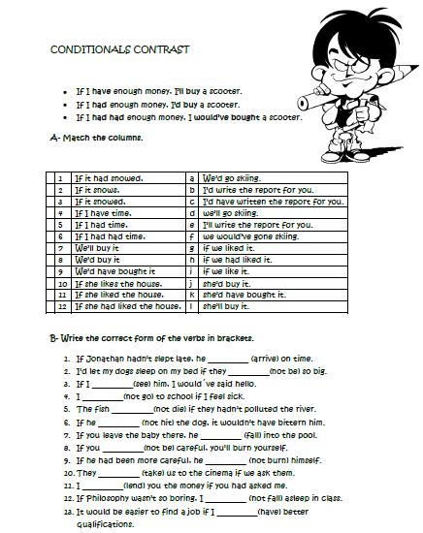

X. Listening

Listen to the people talking about their future plans. Are their plans realistic or not.

XI. Evaluation

XII. Home task
Work book: Ex 1-6 pp.64,65; Crossword puzzle

Prepared by Nataliia Khamuliak

